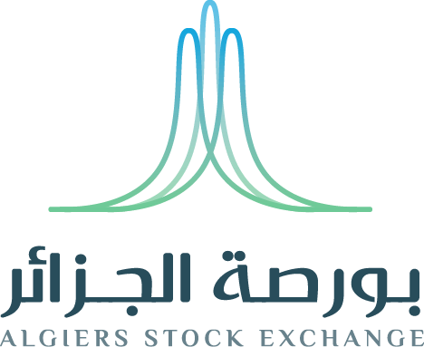
Société de Gestion de la Bourse des Valeurs| 2021

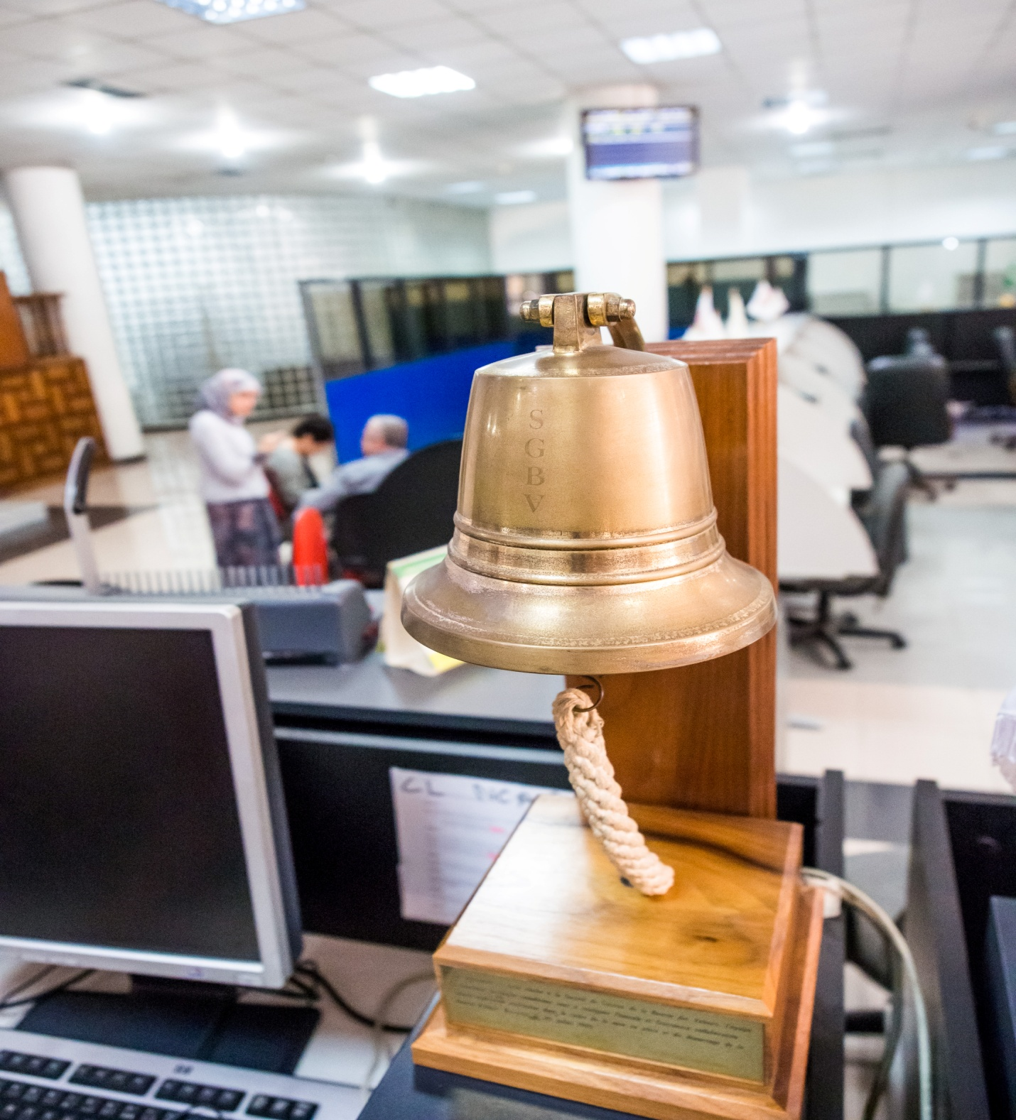
Mai 2021 | RAPPORT MENSUEL DE L’ACTIVITE DE LA BOURSE D’ALGER

Février 2021 | RAPPORT MENSUEL DE L’ACTIVITE DE LA BOURSE D’ALGER

ACTIVITE GLOBALE

L’activité du parquet de la bourse d’Alger pour le mois de mai a enregistré une hausse par rapport au mois d’avril.
En effet, le montant global des transactions s’est inscrit à 11 370 297 DZD, soit une augmentation de l’ordre de 94,57% par apport au mois d’avril, où il a été observé une valeur transigée globale de 5 843 923 DZD.
En ce qui concerne le volume transigé global, il est passé de 9 306 actions en mois d’avril, à 12 455 actions en mois de mai, soit une augmentation de l’ordre de 33,84%.

INDICATEURS DE L'ACTIVITE DE LA BOURSE D'ALGER MOIS DE MAI 2021

Désignation | avril  2021 | mai  2021 | Variation %
Fréquence de cotation | 13 | 12 | -
Nombre d’ordre | 216 | 190 | -12,04%
Volume d’ordre à l’achat | 172 507 | 51 249 | -70,29%
Volume d’ordre à la vente | 30 721 | 41 035 | 33,57%
Valeur transigée (DA) | 5 843 923 | 11 370 297 | 94,57%
Volume transigé | 9 306 | 12 455 | 33,84%
Nombre de transaction | 22 | 42 | 90,91%
Moyenne des transactions par séance | 1,70 | 3,50 | 105,88%
Moyenne des valeurs transigées par séance(DA) | 449 532,54 | 947 524,75 | 110,78%
Moyenne des volumes transigés par séance | 715,85 | 1 037,92 | 44,99%

EVOLUTION DES COURS A LA BOURSE D’ALGER DURANT LE MOIS DE MAI 2021

Action | Cours plus haut(DA) | Cours plus bas(DA) | Cours moyen(DA) | Cours moyen pondéré(DA)
Action
ALLIANCE ASSURANCES | 257 | 257 | 257 | 257
AOM INVEST | - | - | - | -
EGH CHAINE EL AURASSI | 560 | 549 | 558,17 | 560
BIOPHARM | 1 270 | 1 270 | 1 270 | 1 270
SAIDAL | 570 | 543 | 545,35 | 569,35

EVOLUTION DES VOLUMES ET VALEURS TRANSIGES PAR TITRE

Valeurs mobilières | Volume transigé | Valeur transigéeDA | Nombretransactions
ACTION
ALLIANCE ASSURANCES | 81 | 20 817 | 1
AOM INVEST
EGH CHAINE EL AURASSI | 2 000 | 1 120 000 | 10
Biopharm | 6 170 | 7 835 900 | 27
SAIDAl | 4 204 | 2 393 580 | 4
TOTAL | 12 455 | 11 370 297 | 42

ACTIVITE PAR I.O.B (VOLUME TRANSIGE)

I.O.B | Achat client | Achat non client | Vente client | Vente non client
BADR | - | - | 188 | -
BDL
BEA | 2000 | - | 5995 | -
BNA | - | - | 586 | -
BNPPED | 6020 | - | - | -
CNEP-Banque | - | - | 643 | -
CPA | 331 | 4104 | 5043 | -
SGA | - | - | 188 | -
TELL Markets | - | - | - | -

ACTIVITE PAR I.O.B (VALEUR TRANSIGEEDA)

I.O.B | Achat client | Achat non client | Vente client | Vente non client
BADR | - | - | 105280 | -
BDL | - | - | - | -
BEA | 1120000 | - | 7408220 | -
BNA | - | - | 328160 | -
BNPPED | 7645400 | - | - | -
CNEP-Banque | - | - | 664557 | -
CPA | 265617 | 2339280 | 2864080 | -
SGA | - | - | - | -
TELL Markets | - | - | - | -

